Chapter 5 Vocab - The Early Middle Ages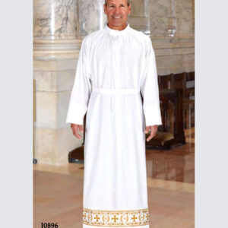

1. Alb - Aubrey Reidhead

The Alb is a garment still commonly seen worn by clergymen and/or servers in churches for certain Christian faiths. (Dictionary.com) The garment is full/floor-length drape-like white linen gown with long sleeves; this is then gathered or cinched at the waist. (Mirriam-Webster) The alb is essentially a white tunic and is quite literally named as such because the Roman garment was called tunica alba: white tunic. (textbook)

Dictionary.com

<https://www.merriam-webster.com/dictionary/alb>

1. Amice- Jamie Rakes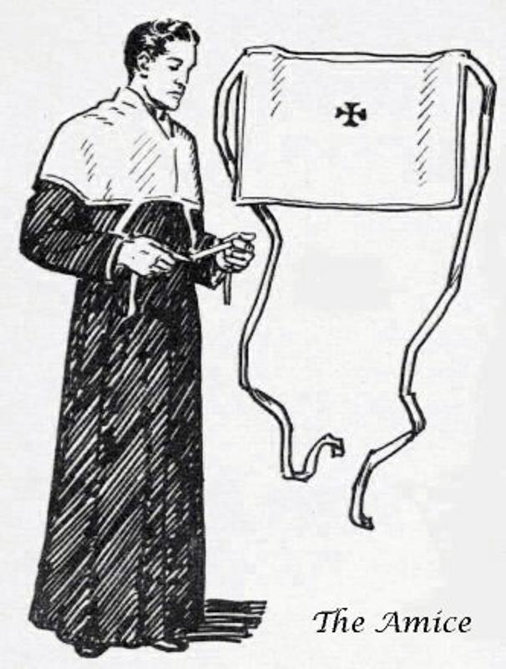

“a white linen cloth worn on the neck and shoulders, under the alb, by a priest celebrating the Eucharist.” (google definition). This is a type of cloth that was worn around the neck and shoulders yet the ties on it started in the front, then wrapped in the back to then be tied in the front. It is really neat while researching this as i found out that “A short linen cloth, square or oblong in shape and, like the other sacerdotal vestments, needing to be blessed before use.” This quote explains how this type of clothing needed to be blessed before using. Lastly this is what the book has to say about the Amice “Amice (am’is) A strip of linen placed around the shoulders and tied in position to form a collar, which was worn by priests saying mass.” So with this information we find out that it is strip of linen worn to make a collar when tied.

<https://www.google.com/search?q=amice&oq=amice&aqs=chrome..69i57j69i60j5l3j69i60l3.1028j0j7&sourceid=chrome&ie=UTF-8>

<https://www.newadvent.org/cathen/01428c.htm>

Text book pg 80

1. Barbette - Hannah Ferreira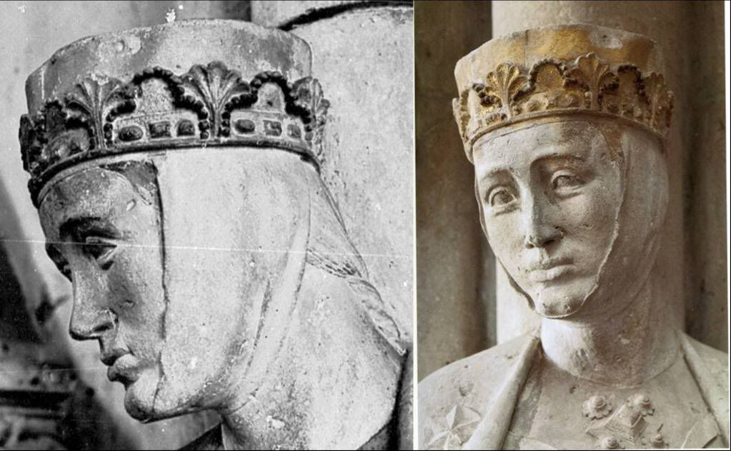

The barbette was a strip of linen that passed from the temple, under the chin, and to the other temple. They were worn with fillets, veils, or sometimes even alone. All classes of women wore them.

Sources:

Book

<https://fashionhistory.fitnyc.edu/barbette/>

https://maniacalmedievalist.wordpress.com/2012/10/10/on-yer-heade-part-ii/

1. Bliaut - Jocelyn Munoz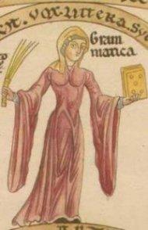

The Bliaut was an overgarment worn by both men and women.

This garment was tied at the sides to better accentuate the figure and was easily identifiable by it’s long sleeves.

From what I was able to find the bliaut and the bliaut gironé were fairly similar and I couldn’t figure out what exactly the differences were. But from what I gathered the gironé skirt was very pleated while it’s more likely the bliaut was much simpler in the skirt. And while both men and women wore bliauts it’s likely that men’s tended to be shorter than the women.

Tortora, P. G., & Marcketti, S. B. (2021). two. In Survey of historic costume (pp. 62, 71). essay, Fairchild Books.

<https://adamselindisdress.wordpress.com/2014/04/28/12th-century-dress-the-bliaut/>

<https://www.encyclopedia.com/fashion/encyclopedias-almanacs-transcripts-and-maps/bliaut>

1. Braies- Debbi Wright

According to our textbook, braies “were loose-fitting linen breeches fastened at the waist with a belt.” So, braies were essentially underwear for men. Sometimes the women wore them too. The Celtic and Germanic tribes wore the braies originally then during the middle ages they were worn by the Europeans. Braies went to the knees or to the mid calf, some even went to the ankle.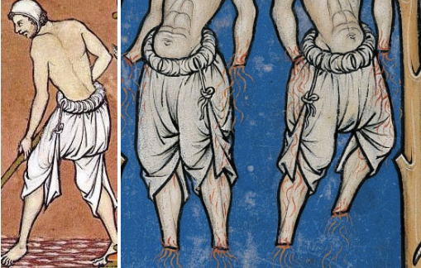

Toratora, Phyllis G, and Keith Eubank. *Survey of Historic Costume, 5th Edition*. Berg, 2009.

<https://armstreet.com/store/medieval-clothing/medieval-underpants>

<https://www.celticwebmerchant.com/en/clothing/middle-ages/braies-clothing/>

<https://en.wikipedia.org/wiki/Braies>

1. Byrnie- **Jessica Fraser**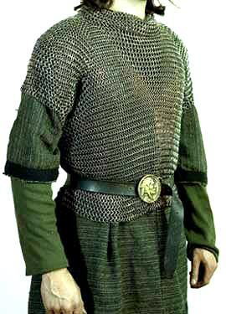

Byrnie is another word for mail shirt. It is a chain-like shirt that goes over clothing to protect soldiers in war. It was short sleeved and made up of iron. As time went on, the Byrnie got longer extending to wrists and down to your knee caps.

I thought it was interesting that just like the warriors, the women dressed in many layers. They also did not wear underwear such as bras.

Sources:

The Book

<https://www.metmuseum.org/toah/hd/arms/hd_arms.htm#:~:text=European%20warriors%20of%20the%20early,derived%20from%20late%20Roman%20types.&text=Body%20armor%20was%20usually%20either,iron%2C%20bronze%2C%20or%20horn>

[(Links to an external site.)](https://www.metmuseum.org/toah/hd/arms/hd_arms.htm#:~:text=European%20warriors%20of%20the%20early,derived%20from%20late%20Roman%20types.&text=Body%20armor%20was%20usually%20either,iron%2C%20bronze%2C%20or%20horn)

<https://www.britannica.com/technology/byrnie>

1. Chainse - Jalissa Cloward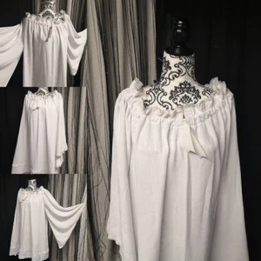

The chainse was an outer garment that was worn over the chemise. It was often made of white linen and was worn by upper-class women. It was pleated and long. The chainse was washable and was a “house dress” of sorts. It could be worn alone or with other outer garments to make it less casual.

*Survey of Historic Costume* pg. 132

<https://www.wordsense.eu/chainse/>

<https://quod.lib.umich.edu/m/moajrnl/acw8433.1-14.342/470:5?page=root;size=100;view=text>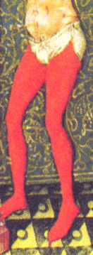

1. Chausses- **Amanda Hair**

Chausses were leg protectors that were part of the military costume in the early middle ages. Some covered only the front of the leg, but other wrapped around the whole leg. Another word for them is “shos.” The Met Museum website explains that these were commonly worn by mounted warriors. Later, boiled leather or steel pieces protected the knees (kneecops), while small squares of the same hard materials covered the vulnerable shoulder joints (ailettes).” At other times it is believed that they were made of a quilted stocking type material.

<https://www.metmuseum.org/toah/hd/arms/hd_arms.htm>

Survey of Historic Costume, Page 139

<https://medievalextreme.com/under-armor-padding/padded-legs-chauses/#:~:text=In%20the%20early%20Middle%20Ages,XIth%20to%20the%20XVth%20centuries>.

1. Chasuble**- Ryann Becker** 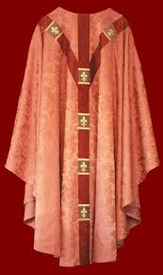

This is a type of cape worn by the clergy. It was adapted from the Roman cape called a paenula. Though a Chasuble had the sides shorter for movement of the arms. An Orphrey, which is a band of embroidery that goes over the shoulders and forms a vertical line in the front and back. This band was worn over the Chasuble. This piece of garment is blessed before it is worn to perform religious ceremonies.

Textbook page 120

<https://www.newadvent.org/cathen/03639a.htm>

<https://www.merriam-webster.com/dictionary/chasuble>

1. Chemise- Samantha Hooper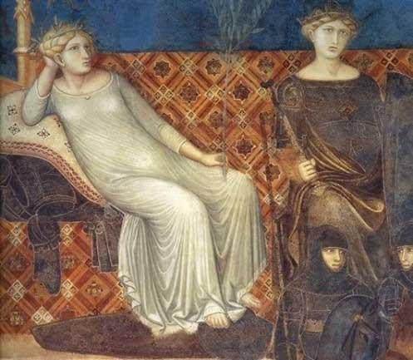

The chemise is a loose undergarment typically made of linen. It was the layer worn closest to the skin and is most comparable to a slip today. It protected the outer layers of clothing from sweat and body oils. The chemise was one of the only garments that was regularly washed and it provided longevity to the other garments, making it so that they could be washed less frequently.

Book

<https://rosaliegilbert.com/chemises.html#:~:text=The%20chemise%2C%20shift%20or%20smock%20was%20the%20innermost%20layer%20of,layers%20smelling%20fresher%20for%20longer>

<https://en.wikipedia.org/wiki/Chemise>

1. Cloak-Savannah Tanner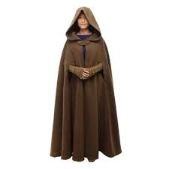

Cloaks came in many different styles. Cloaks were commonly a semicircular material typically draped around the shoulders area. Cloaks became less popular as sewing machines became more common. Cloaks varied in length.

<http://www.historyofclothing.com/clothing-history/cloak/>

<https://fashion-era.com/coats_history/cloak_costume_history_2.htm>

Pg 114

1. Closed Mantle-Abigail Storrer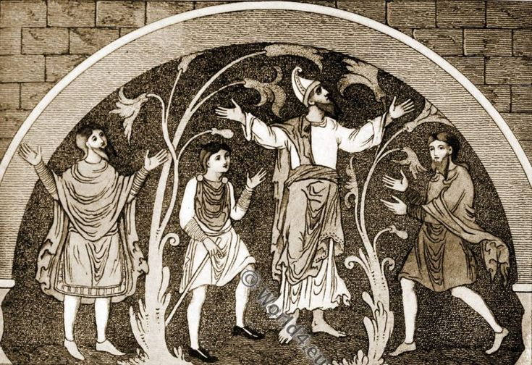

First guy on the left

The closed mantle was worn by men in the tenth and eleventh centuries. It was a piece of fabric with a slit in it that allowed the head to go through. The earlier mantel was plane and became more decorated as time passed.

Survey of Historic Costume, pg 127

<https://www.worldhistory.org/article/1248/clothes-in-medieval-england/>

<https://world4.eu/anglo-saxon/>

<https://www.pinterest.es/pin/300896818856132746/>

1. Coif - Hailey Child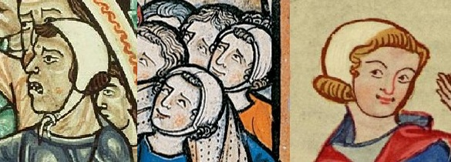

A coif, also referred to as a cap or a hood, is a close fitting hat secured under the chin. It serves many purposes including, keeping the sun off from your head, and keeping your head warm in the night. It covers all of the back, sides, and top of the head. Worn by both men and woman, the actual word “coif” derives from the old French word, “coife” meaning headdress.

<https://trc-leiden.nl/trc-needles/individual-textiles-and-textile-types/daily-and-general-garments-and-textiles/coif#:~:text=A%20coif%20is%20a%20close,modern%20coiffe>)%20meaning%20a%20headdress.

Survey of Historic Costume

<https://maniacalmedievalist.wordpress.com/2012/11/02/pattern-your-own-simple-coif-unpadded-arming-cap/>

1. Cope - Jensen Stenquist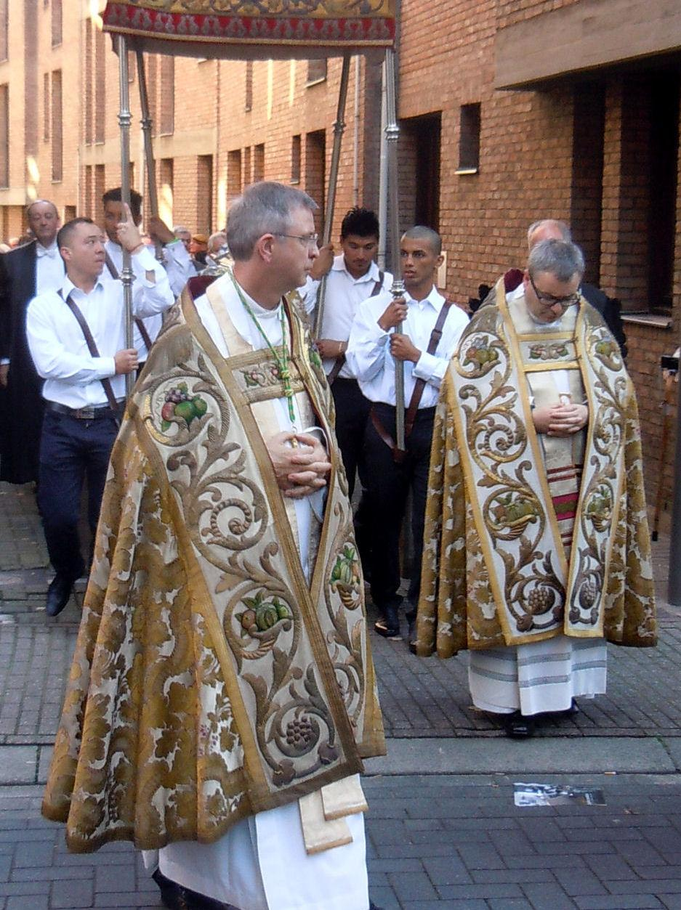

The cope is a voluminous cape that was worn for processions. A full-length cloak formed from a semicircular piece of cloth, it is open at the front and is fastened at the breast by hooks or a brooch. It is made of [silk](https://www.britannica.com/topic/silk) or other rich material in various colors. The cope is a religious garment from the earliest ages. In art, angels were often shown wearing copes. It was worn by the Roman Catholics and some Angelican clergy. “The cope is a vestment for processions worn by all ranks of the clergy when assisting at a liturgical function, but it is never worn by the priest and his sacred ministers in celebrating the Mass.”

<https://www.britannica.com/topic/cope>

Tortora, P. G., & Marcketti, S. B. (2021). *Survey of historic costume*. Fairchild Books.

<https://en.wikipedia.org/wiki/Cope>

1. Cornette - Irelynd Preece 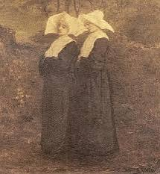

The cornette was a distinctive piece of clothing that was worn in modern times. It was said to be a religious habit that nuns also wore. The cornette was worn by females on their heads. On it was a piece of white cloth that is folded upwards to resemble horns. Hanging down the back from the hood was a long tube of fabric.

Sources:

Textbook page 137

<https://en.m.wikipedia.org/wiki/Cornette#Use_by_the_Daughters_of_Charity>

<https://religion.fandom.com/wiki/Cornette>

1. Cote: - Zaya Weight

In the 13th Century terminology changed a bit. The cote is essentially the same as the undertunic from previous times under a different name. They were garments worn over a chemise (undershirt) & often under a surcote (outer tunic) but not always. They were made of either wool or linen fabric, brighter colors of which were less available to common people. Sleeves were most frequently either tightly fitted to the arm or cut quite wide under the arm & tapered down to be fitted around the wrist. The wealthier classes tended to have longer ones while the lower classes had shorter, more practical cotes. Women’s cotes were always long. Cotes sometimes had a slit up the front of the skirted portion for greater mobility & it also made it so someone doing labor could easily tuck the corners of the split into their belt for even great range of movement. 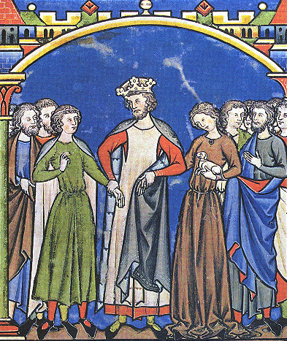

Textbook 135-137

The Medieval Tailor’s Assistant, chapter 4

[Getting Dressed in the 14th Century](https://www.youtube.com/watch?v=RNAMbRt5eI8&t=141)

1. Double Mantle-Anna Ament 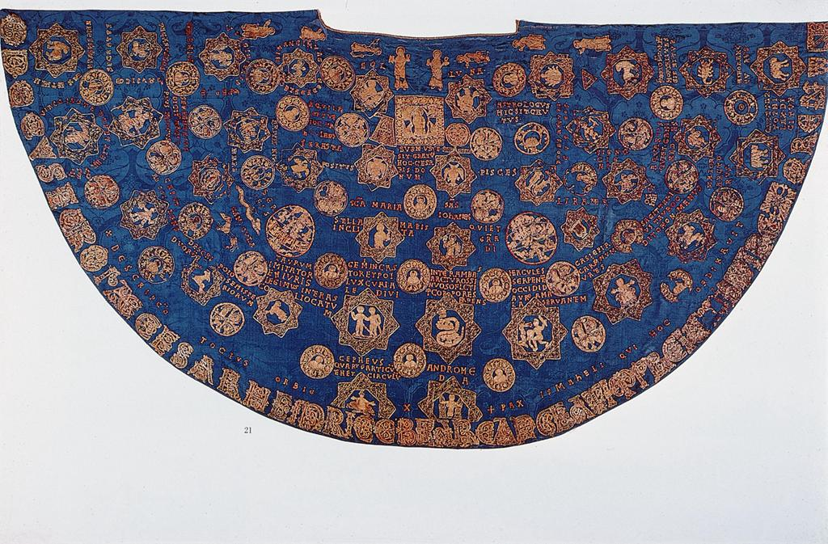

Similar to a cloak was the early medieval mantle. The mantles went on top of all other clothing and contributed to a person's warmth in cold places. Over time, the mantle developed into a more uniform style of the cape with tassels. However, in the early medieval times, the mantle was much more of a vague piece of fabric draped over the clothing. It is suspected that people would use old capes to cut into mantles later. Because mantles were used for cold weather, they were often made of fur or wool to keep the individual warm. From descriptions we can interpret that they were of many colors and designs.

sources:

<https://library.princeton.edu/news/marquand/2017-03-31/1754-celebration-medieval-mantles>

<https://rosaliegilbert.com/cloaksandmantles.html>

1. Fillet - Esther Wambold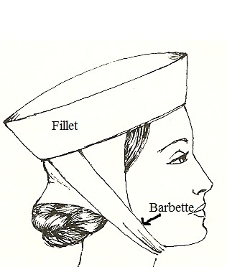

A fillet is a stiff linen band that was used to secure a woman’s veil. Upper Class women would embroider and add embellishments to theirs, while working-class women might have smaller, simpler ones.

Rosalie’s Medieval Woman - Medieval Headwear. (2022). Rosaliegilbert.com. <https://rosaliegilbert.com/headwear.html>

maniacalmedievalist. (2012, October 10). *On Yer Heade: Part II*. Maniacal Medievalist; Maniacal Medievalist. <https://maniacalmedievalist.wordpress.com/2012/10/10/on-yer-heade-part-ii/>

Wikipedia Contributors. (2021, November 22). *Fillet (clothing)*. Wikipedia; Wikimedia Foundation. <https://en.wikipedia.org/wiki/Fillet_(clothing)>

1. Fitchets
2. Gardecors, Gardecorp- Bailey Pinder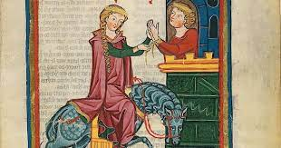

From descriptions, this seems to have been the same kind of garment as the herigaut. It was a full garment with long and wide sleeves and a slit below the shoulder where an arm could be slipped through. It also usually had a hood. It was the top layer so it was worn on top of everything else. It was worn by both men and women. Men wore it for military purposes while women wore it for travel.

<http://evashistoricalcostumes.blogspot.com/p/a-pink-gardecorps-from-c-1300.html>

<https://books.google.com/books?id=JvKjCwAAQBAJ&pg=PA103&lpg=PA103&dq=gardecors+clothing+history&source=bl&ots=N8ZR8-Txki&sig=ACfU3U3SKC5kR0vRu3FiT5zP5XwALX-qQg&hl=en&sa=X&ved=2ahUKEwiYh9yfitD1AhW0IDQIHazuB5wQ6AF6BAgUEAM#v=onepage&q=gardecors%20clothing%20history&f=false>

Survey of Historic Costume pg 136

1. Garnache - Kya Boyd 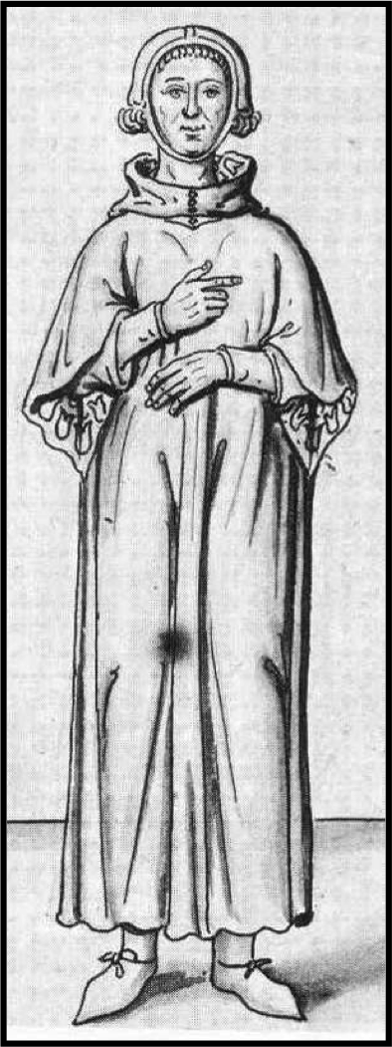

A long coat with cape-like sleeves often lined or collared with fur, this garment was open at the sides under the arms. Worn by men in all social classes containing a thicker wool to protect them from cooler weather and keep them warm. The ganache originated from France based as a religious wear similar to the monks' way of wearing their cloth.

Sources :

The Book

<https://www.stronghold-nation.com/history/ref/ganache><http://www.fashionencyclopedia.com/fashion_costume_culture/Early-Cultures-Europe-in-the-Middle-Ages/Ganache-and-Gardcorps.html>

1. Gartered Hose - Abby Fluckiger

Hose were stockings or long socks reaching up over the knee for modesty and warmth. They were an essential part of both men and women’s wardrobes. Since pattern cutting was still very simple and producing a pair of hose that fit well enough not to slip or shift was just about impossible, garters were necessary to hold them up. The garters would have been strips of fabric, ribbon, or tape tied just below the knee, either in a straight line or cross-gartered.

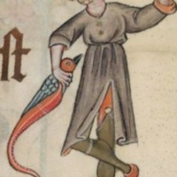 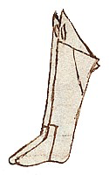

Textbook pages 118 and 119

<https://rosaliegilbert.com/hose.html>

<https://medievallondon.ace.fordham.edu/exhibits/show/medieval-london-objects-3/fringed-garter>

1. Girdles- Aniston
2. Hauberk - Claire Lynes
3. Herigauth- **Abbie Burns**

This article of clothing consisted of wide sleeves, a slit slightly below the shoulder which made an opening for the arms to go through creating an opening for the arm to go through. This created a long full sleeve hanging behind. The garment went between three quarters to full length. Occasionally the sleeves were tucked at the bottom to create fullness below. Alternative words for this garment are herigald, heregaud, gerygoud and herigans.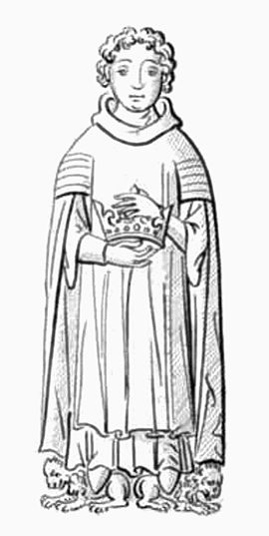

Source:

Book 136

<https://www.countylinemagazine.com/county-line-blog/herigaut/article_efde2c10-92b8-11e9-91f7-87258b031eab.html>

<https://en.wikipedia.org/wiki/Herigaut>

1. Hose- Lauren Shumway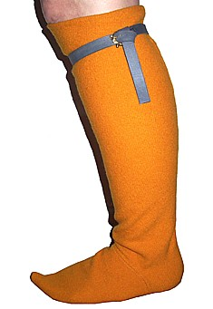

Hose in the Medieval period where wool sock-like garments worn by both men and women. Hose was made from loose woven fabrics made to be as tight as possible the fabric was cut diagonally or on the bias to make the fit as close to the leg as they were seen being made with either one or two seams. Hose ending at the thigh or the knee and were tied into place with garters

A Survey of Historic Costume, 117,129,134,137

A History of costume, Carl Kohler,181

<https://www.encyclopedia.com/sports-and-everyday-life/fashion-and-clothing/clothing-jewelry-and-personal-adornment/hose-and-breeches>

1. Liripipe- Brittany Pocock

A liripipe was the part of the hood that hung long in the back. The tassel on graduation caps comes from this. By the 15 century it was worn around the neck and head. It is often associated with academics. Sometimes the length was as long as six feet. It started the robin hood style hiding cap. 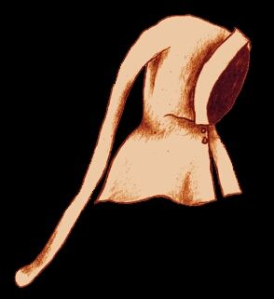

[Liripipe Definition & Meaning - Merriam-Webster](https://www.merriam-webster.com/dictionary/liripipe)

[Liripipe - Wikipedia](https://en.wikipedia.org/wiki/Liripipe)

Book

1. Mantle - Kimberly Tesam Moita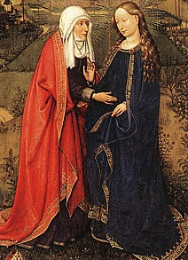

Mantles were cloaks that were worn by both men and women, and were usually square during the 20th century, until later there were more semicircular mantles. Men of important status in society in the Middle Ages wore mantle-like Greek himations for special ceremonial events. Women wore both open or closed mantles, and some were made with multiple colors as well as fur-lined winter mantles for colder months.

<https://theodora.com/encyclopedia/m/mantle.html>

<https://rosaliegilbert.com/cloaksandmantles.html#:~:text=Known%20as%20British%20cloaks%2C%20they,clothing%20in%20the%20middle%20ages>.

1. Open Mantle- Marisol Dejesus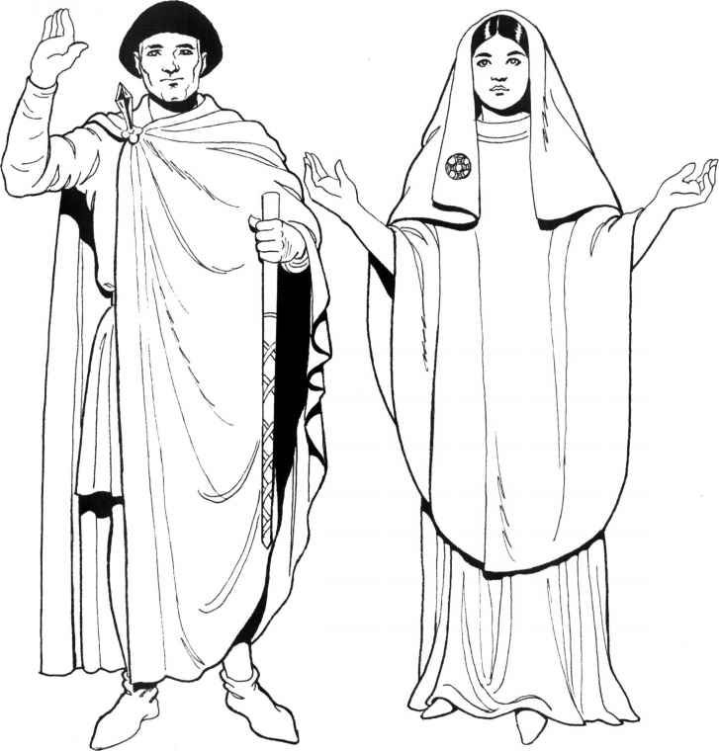

Open mantle is made of one piece of fabric. The fabric is secure on one shoulder. Worn constantly throughout the Middle age. They came from the mantle.

Source:

Book pg.127

<https://earlymiddleages.wordpress.com/menswear/>

<http://www.fashionencyclopedia.com/fashion_costume_culture/Early-Cultures-Europe-in-the-Middle-Ages/Mantle.html>

1. Outer Tunic
2. Pallium - Alex Clark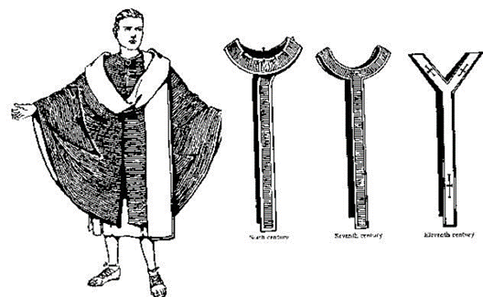

The pallium was a long and heavily jeweled scarf that was thought to have evolved from the toga. It was an article of clothing that was the official insignia of the emperor, the empress was also allowed to wear this piece of clothing. The pallium in the present day can be seen within the Catholic Church for the Pope and metropolitan bishops. One of the ways the pallium is made within the Catholic Church is by blessing two lambs and using their wool to create the scarf. This tradition of making the pallium has continued for over 500 years.

**Sources:**

<https://www.pinterest.com/pin/858920960159043919/>

<https://en.wikipedia.org/wiki/Pallium>

<https://www.irenebrination.com/irenebrination_notes_on_a/2019/01/st-agnes-lambs-pallium.html>

Survey of Historic Costume, Page 112

1. Paludamentum- Andrea Lazaro Hernandez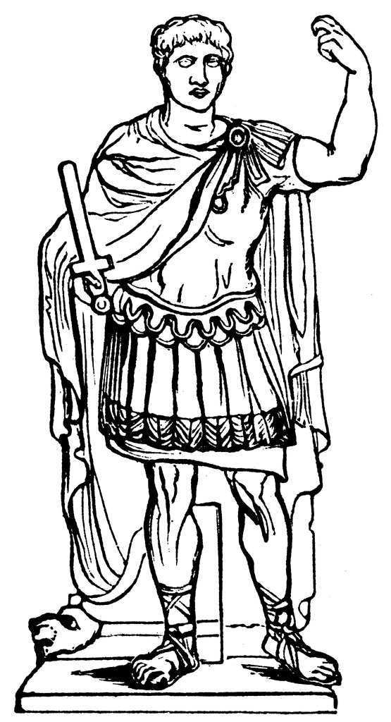

During the Byzantine empire, the paludamentum was a type of cloak worn by both men and women of the upper class on top of their regular clothes (men’s tunic and dalmatic, and women’s stola and palla). Paludamentum were of different shapes,either semicircular or trapezoid, and they were secured on the right shoulder by a jeweled brooch. The Paludamentum was also worn during the Roman empire by military officers and generals.

Sources:

Survey of Historic Costume, page 114

<http://www.fashionencyclopedia.com/fashion_costume_culture/Early-Cultures-The-Byzantine-Empire/Paludamentum.html>

[https://penelope.uchicago.edu/Thayer/E/Roman/Texts/secondary/SMIGRA*/Paludamentum.html](https://penelope.uchicago.edu/Thayer/E/Roman/Texts/secondary/SMIGRA*/Paludamentum.html)

1. Pelicon, Pelice: Lexie Pincock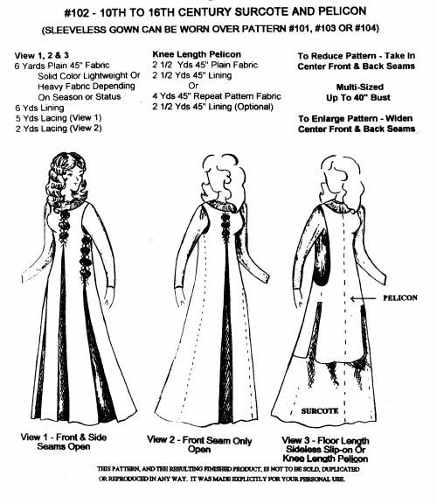

A term that references any number of fur-trimmed garments. Some of these types include: outer wraps, under tunics, and outer tunics. Also considered an over dress to be worn indoors to help women stay warm during the winter.

Sources:

<http://ruthjohnston.com/AllThingsMedieval/?p=304>

Pg. 132

1. Segmentae (lena Kawakami) 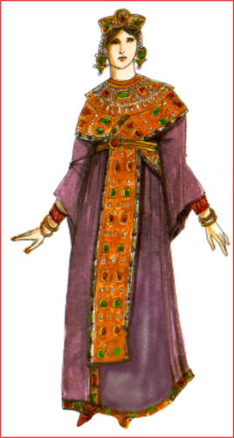

A segmentae is a type of trim on tunics and garments from the Byzantine people whose trim or decoration was square or medallion shaped and were don’t in a tapestry weave. From the other things I read, segmentae can mean a decorated tunic. But The decoration part is actually what the segmentae is here is a picture [https://blacktauna.tripod.com/byzantineclothinginfo.htm](https://blacktauna.tripod.com/byzantineclothinginfo.html) <https://lowelldesigns.com/the-byzantine-empire/>

Something I thought was interesting about the video was that they used horse hair as hair extensions back then.

1. Stole - Savannah Jeppson

A stole is the long, narrow strip of material, which was worn over the shoulder during the mass. A [bishop](https://en.wikipedia.org/wiki/Bishop) or other [priest](https://en.wikipedia.org/wiki/Priest) in the Roman Catholic religion, wears the stole around his neck with the ends hanging down in front, while the [deacon](https://en.wikipedia.org/wiki/Deacon) places it over his left shoulder and ties it cross-wise at his right side, similar to a sash. It also symbolizes immortality in the Roman Catholic Church and is conferred at ordination.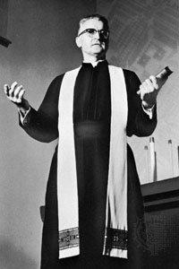

Sources:

The Book

<https://en.wikipedia.org/wiki/Stole_(vestment)#:~:text=In%20the%20Latin%20Catholic%20tradition,marks%20recipients%20of%20Holy%20Orders.&text=A%20bishop%20or%20other%20priest,side%2C%20similar%20to%20a%20sash>.

<https://www.britannica.com/topic/stole>

1. Surcote- Elizabeth Nathan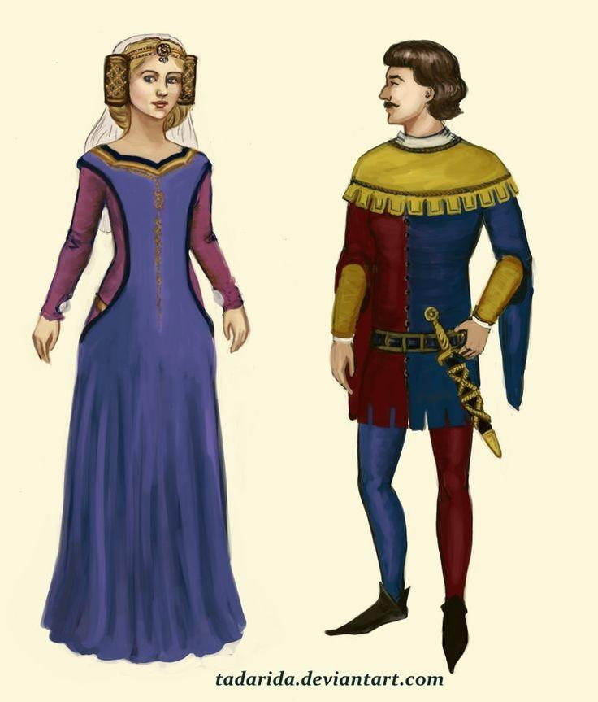

Surcoat was a sleeved or sleeveless outer garment worn by European men and women during the 13th and 14th centuries. The surcoat for men was usually a tunic, or simple piece of material with a hole for the head, often worn over armor. For women, the surcoat was a more significant and characteristic garment, which originated in the 13th century as a voluminous outer cloak. Also in the beginning of the 14th century the armholes were turned into long open slits to the hips and neck was cut low to create a narrow strip over the shoulders.

<https://www.britannica.com/topic/surcoat>

<https://en.wikipedia.org/wiki/Surcoat>

Survey of Historic costume page 135

1. Tabard-Ida Johnson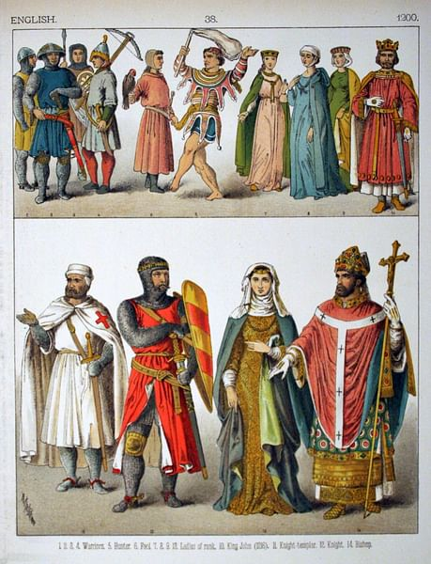

Short, loose garment with short or no sleeves, and open sided. Originally worn by monks, and then the military. In the military, tabards were often decorated with a coat of arms, emblems that featured different symbols and which were claimed as a kind of family seal.

<http://www.fashionencyclopedia.com/fashion_costume_culture/Early-Cultures-Europe-in-the-Middle-Ages/Tabard.html>

.

1. Under Tunic
2. Wimple- Claire Moore

A wimple is a headdress that was worn by women. It was often made out of linen of silk. It was worn by married women since it was frowned upon for them to show their hair. It also covers the womens neck, cheeks, and chin.

sources

<https://www.britannica.com/topic/wimple>

[(Links to an external site.)](https://www.britannica.com/topic/wimple)

<https://en.wikipedia.org/wiki/Wimple>

[(Links to an external site.)](https://en.wikipedia.org/wiki/Wimple)

page 137

1. Winter Mantle - Marisa Bone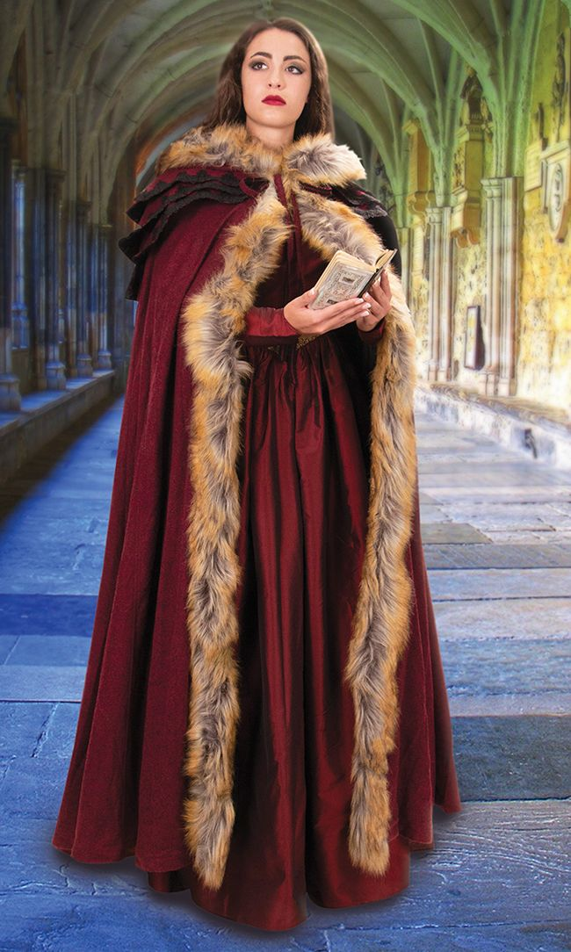

The winter Mantle is a form of medieval shoulder cape or cloak worn in the winter to keep the wearer warm and would usually have fur lining. Surviving the winter in the middle ages could be typically difficult and the mantle would be worn indoors and outdoors. It would be rare to wash this outer garment and with the amount of time spent around smoke the mantle would act as a natural deodorant eliminating odors through the campfire smell.

Sources

Book: Page 128

[Source 1](https://www.worldhistory.org/article/1248/clothes-in-medieval-england/)  [Source 2](https://www.sarahwoodbury.com/how-did-medieval-people-keep-warm/)